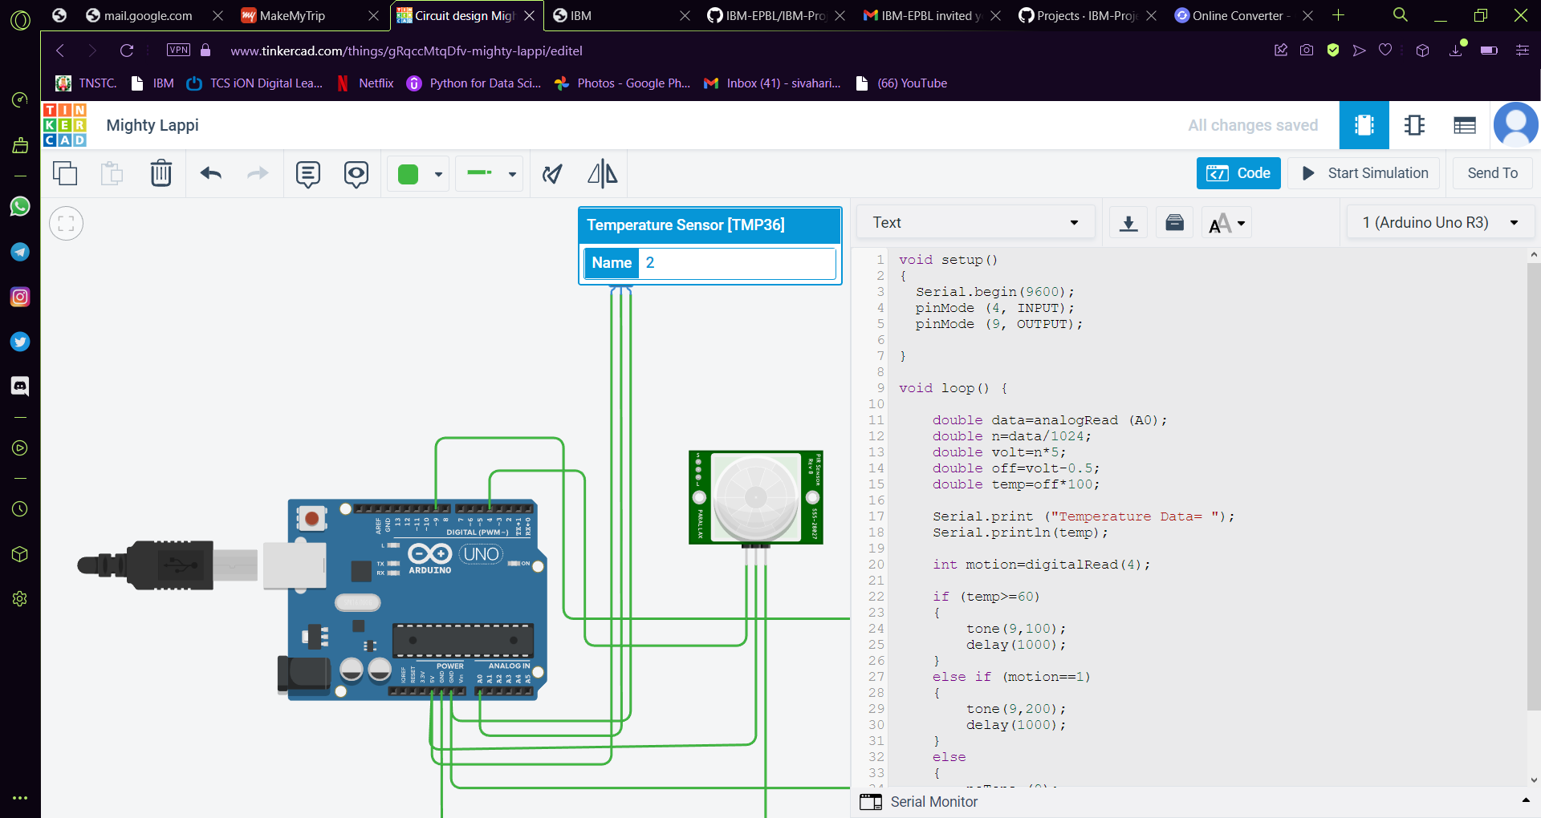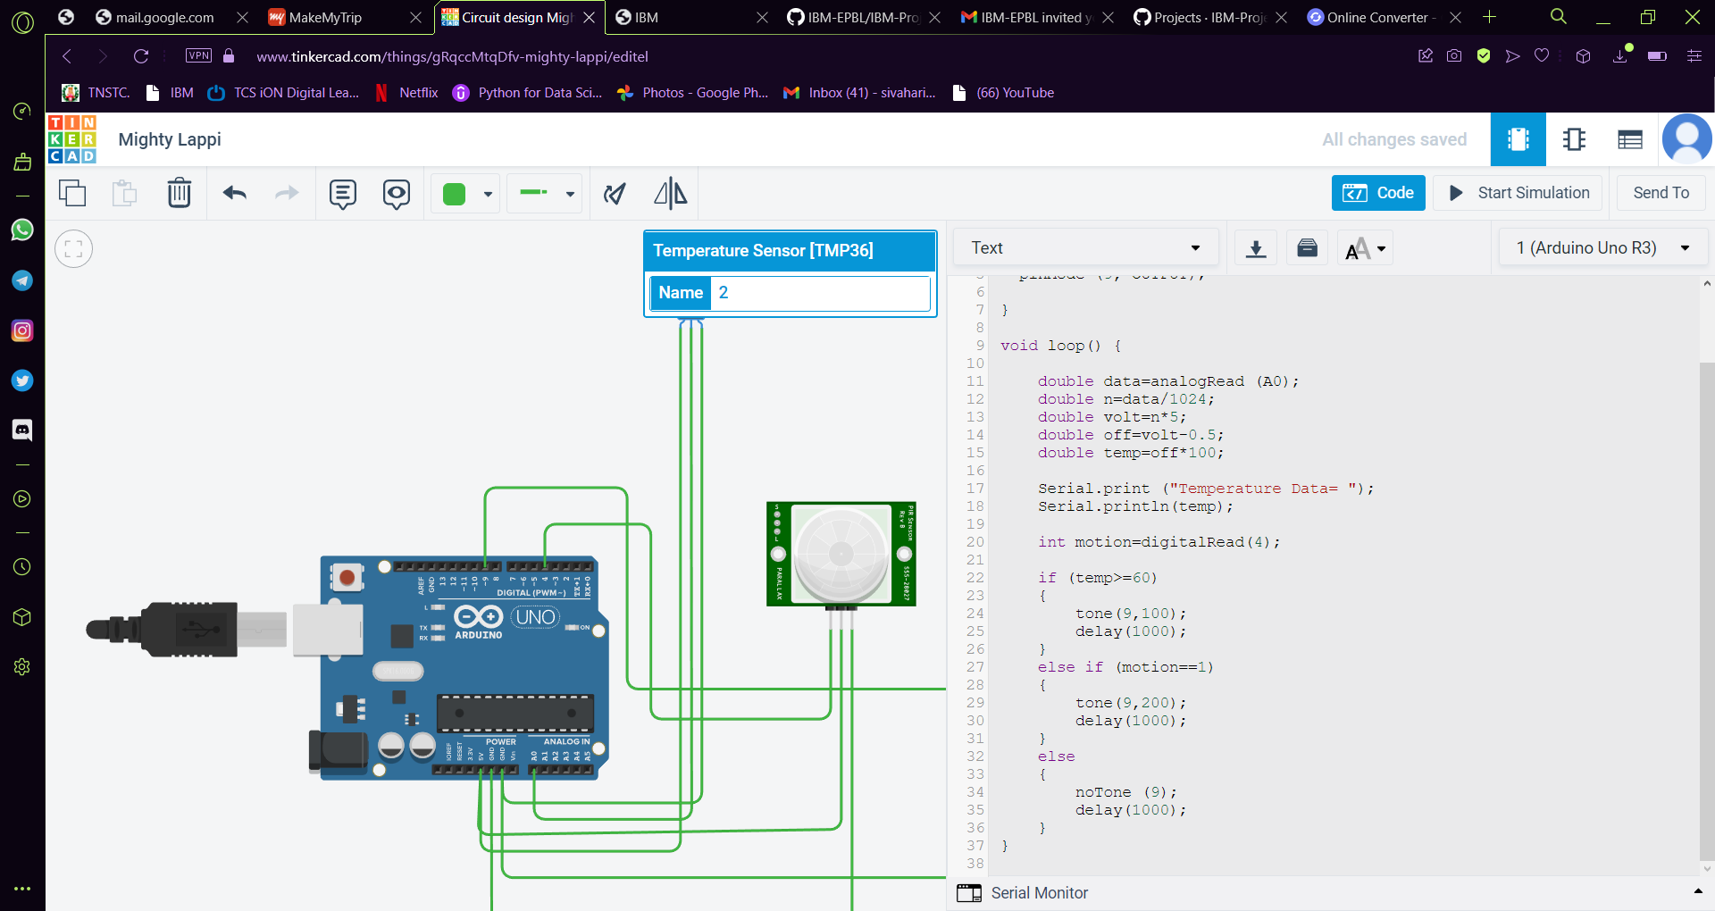

**Code**

void setup()

{

Serial.begin(9600);

pinMode (4, INPUT);

pinMode (9, OUTPUT);

}

void loop() {

double data=analogRead (A0);

double n=data/1024;

double volt=n*5;

double off=volt-0.5;

double temp=off*100;

Serial.print ("Temperature Data= ");

Serial.println(temp);

int motion=digitalRead(4);

if (temp>=60)

{

tone(9,100);

delay(1000);

}

else if (motion==1)

{

tone(9,200);

delay(1000);

}

else

{

noTone (9);

delay(1000)

}

}

**Output** 